# WRS Permission Levels and Groups

## Remember to use a SQL Server Alias

### Site Permissions

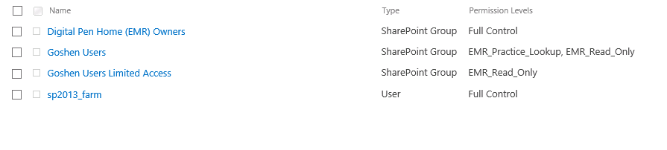

### Permission Levels

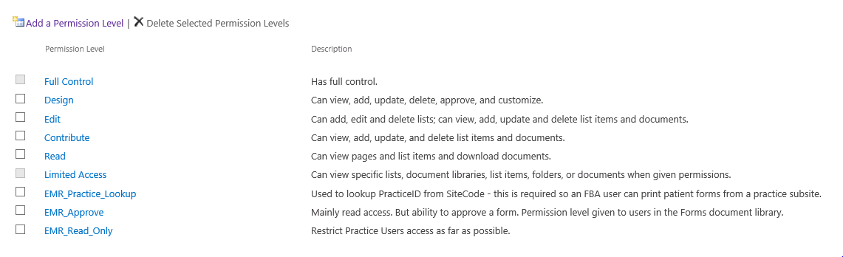

|  |  |  |
| --- | --- | --- |
| Permission Level | List Permissions | Site Permissions |
| EMR_Practice_Lookup  Used to lookup PracticeID from SiteCode - this is required so an FBA user can print patient forms from a practice subsite. | View Items | View Pages, Use Remote Interfaces, Open |
| EMR_Approve Mainly read access. But ability to approve a form. Permission level given to users in the Forms document library. | Edit Items, View Items, View Application Pages | View Pages, Use Remote Interfaces, Open |
| EMR_Edit Mainly read access. But ability to edit is given so that practice users can add new Patient. Permission level given to practice users in the Patients list. | Edit Items, View Items, View Application Pages | View Pages, Use Remote Interfaces, Open |
| EMR_Read_Only Restrict Practice Users access as far as possible. | View Items | View Pages, Use Remote Interfaces |
|  |  |  |

### EMR Root Site - Groups

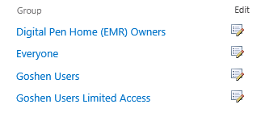

### EMR Owners Group

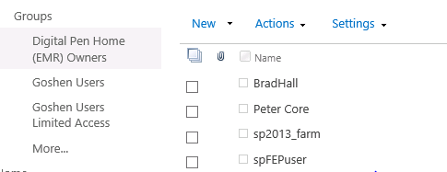

### Goshen User Group

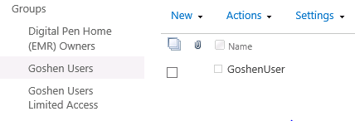

## Customer Subsites

Subsites have Unique Permissions

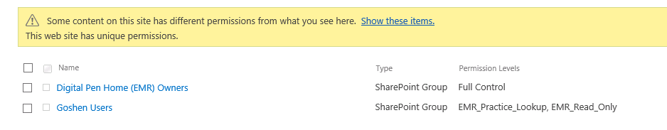

New Forms has unique permissions (but this could change if approval implemeted via workflow)

